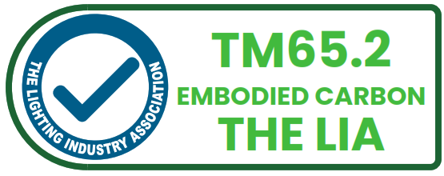
- The Mark consists of the TM65.2 Assured Product Verification Certification mark (The Mark).
- The Mark shall only be used by customers that have successfully completed all stages of the LIA circular economy certification scheme process (certification scheme TSD-016 TM65.2 Assured Product Verification Scheme).
- The Mark shall only be used once a certificate has been issued by the LIA for the scope of certified product(s) identified in the certificate.
- The Mark shall not be used to imply that non-certified product(s) are covered under the certificate.
- The Mark shall not be used without indicating that it is a certification mark.

TM65.2 Product Conformity Certification Mark
- The Mark consists of the mark as shown in Appendix A (Item A). There are three different designs of the Mark available
- Landscape,
- Portrait – Green Bottom, and
The Mark is available in colour and in black&white (refer to Appendix A).
- The Mark as shown in Appendix A, with written approval from the LIA shall only be used on:
  - Packaging and Product Literature of products within the scope of certified products identified in the certificate only (e.g. Installation Instructions, Product packaging, Product marking label, etc.).
- The Mark will be provided in ai. and png. formats. Other formats are available on request.
- The user of the Mark can refer on the website to the LIA certificate and can provide a link to the certification database, where validity of the certificate can be verified.
- The Mark shall only be used in its entirety, and without amendment as shown in Appendix A. For specific guidance on minimum size, position and backgrounds, please refer to Appendix B.
- The relative proportions of the Mark shall always be retained. Any change in size to the mark must retain the correct proportions.
- When marking certified products, no method other than direct printing on the product packaging shall be used unless agreed in writing by the LIA.
- The user of the Mark shall at the request of the LIA cease to use the mark if the LIA deems the application inappropriate.
- The user of the Mark shall, upon suspension of agreement, immediately discontinue the issue of documents that display the mark or contain reference to the LIA/.
- The user of the Mark shall, upon termination of the agreement, shall immediately remove any mentions or links about the product certification from user’s website.
- In using the Mark, the user agrees to be bound by the above conditions. Failure to comply with the above conditions for use of the mark may result in withdrawal of agreement and legal action.

APPENDIX A
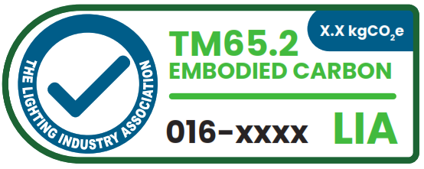
The Mark – Landscape (Colour)
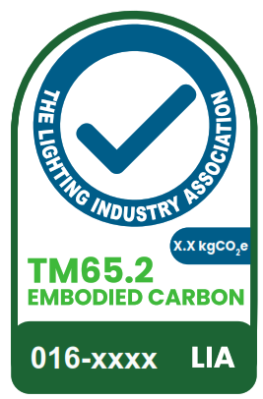
The Mark – Portrait – Green Bottom (Colour)
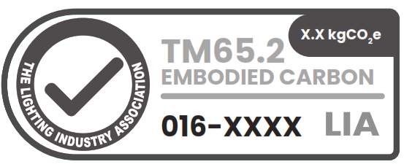
The Mark – Landscape (Black&White)
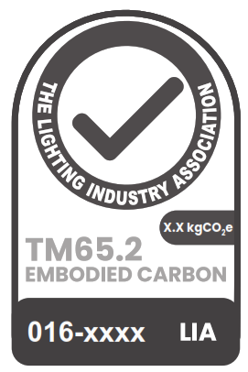
The Mark – Portrait – Green Bottom (Black&White)

APPENDIX B
Usage – Sizes
Item A – Landscape Logos
Item A – Landscape Logos | Minimum Width |  | Minimum Height |  |  | Maximum Width |  |  | Maximum Height
Stationery | 55mm |  | 21mm |  |  | 100mm |  |  | 37mm
Promotional | 55mm |  | 21mm |  |  | 100mm |  |  | 37mm
Signage | TBA with LIA |  | TBA with LIA |  |  | TBA with LIA |  |  | TBA with LIA
Item B – Portrait Logos
 | Minimum Width |  | Minimum Height |  |  | Maximum Width |  |  | Maximum Height
Stationery | 20mm |  | 30mm |  |  | 43mm |  |  | 70mm
Promotional | 20mm |  | 30mm |  |  | 43mm |  |  | 70mm
Signage | TBA with LIA |  | TBA with LIA |  |  | TBA with LIA |  |  | TBA with LIA
Colours | CMYK |  |  |  |  |  | RGB
Colours | C | M |  | Y | K |  | R | G |  | B
Light Green | 75 | 0 |  | 100 | 0 |  | 57 | 181 |  | 74
Dark Green | 90 | 30 |  | 95 | 30 |  | 0 | 104 |  | 56
Blue | 100 | 0 |  | 0 | 50 |  | 0 | 105 |  | 145
White | 0 | 0 |  | 0 | 0 |  | 255 | 255 |  | 255

Backgrounds
Correct
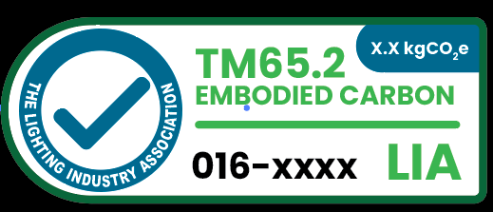
Correct
Incorrect

